

ITSimplera Institute
System Administration & Infrastructure Services Internship

WEEK 1 — TASK 01
Building Your Professional Virtual Lab Environment

Submitted By:
HRITHIKA S
Registration No: SAB01-0771
Email: hrithistar@gmail.com
Issued By:
Tahir Zaman
Team Lead – System Administration & Infrastructure Services
Released: June 27, 2026 | Deadline: July 4, 2026
Difficulty: Beginner | Task Type: Theory + Virtualization + Windows Deployment

Table of Contents

1. Introduction ...... 3
2. Objective ...... 3
3. Theory Topics ...... 4
3.1 Introduction to MCSE ...... 4
3.2 Role of a System Administrator ...... 4
3.3 Cloud Computing Fundamentals ...... 5
3.4 Virtualization Technologies ...... 5
3.5 Hypervisors — Type-1 vs Type-2 ...... 6
3.6 VMware Workstation Overview ...... 6
3.7 Windows 10 Architecture ...... 7
3.8 Windows Installation Process ...... 7
3.9 Windows Disk Management ...... 8
3.10 DiskPart CLI Commands ...... 8
4. Software Requirements ...... 9
5. Practical Implementation ...... 9
5A VMware Installation ...... 9
5B Virtual Machine Creation ...... 10
5C Windows 10 Installation ...... 11
5D Disk Management with DiskPart ...... 12
5E Complete Windows Setup ...... 14
6. DiskPart Command Explanation ...... 12
7. Challenges Faced ...... 15
8. Learning Outcomes ...... 15
9. Conclusion ...... 16
10. References ...... 16
11. Evaluation Criteria ...... 17

1. Introduction

This report documents the complete implementation of Week 1 — Task 01 of the ITSimplera Institute System Administration & Infrastructure Services Internship. The task focuses on building a professional virtual lab environment using VMware Workstation and Windows 10, which forms the foundational platform for all future internship assignments.
Virtualization is a cornerstone technology in modern IT infrastructure. By creating an isolated, controlled environment inside a virtual machine, system administrators can safely experiment, configure, and test systems without risking production infrastructure. This task bridges theoretical understanding with practical hands-on deployment.
The implementation covers VMware Workstation installation, virtual machine configuration, Windows 10 deployment, and professional disk partitioning using DiskPart CLI — all essential skills for a Microsoft Certified Solutions Expert (MCSE).

2. Objective

The primary objectives of this task are:
- Familiarise interns with core concepts of MCSE, Cloud Computing, and Virtualization Technologies.
- Install and configure VMware Workstation Pro as the hypervisor platform.
- Create a properly configured Windows 10 (64-bit) virtual machine.
- Install Windows 10 using the Custom Installation method with professional settings.
- Perform professional disk partitioning using the DiskPart command-line utility during Windows Setup.
- Document the entire deployment process with screenshots and explanations.
- Build a reliable lab environment to be used for all future internship tasks.

3. Theory Topics

3.1 Introduction to MCSE (Microsoft Certified Solutions Expert)
Microsoft Certified Solutions Expert (MCSE) is a globally recognised professional certification program offered by Microsoft. It validates advanced skills in designing, implementing, and managing enterprise-level solutions using Microsoft technologies.
MCSE certifications cover multiple specialisations including:
- Cloud Platform & Infrastructure (Azure, Hyper-V, Storage)
- Productivity (Exchange, SharePoint, Skype for Business)
- Data Management & Analytics (SQL Server, Business Intelligence)
- Core Infrastructure (Windows Server, Networking)
Holding an MCSE certification demonstrates that a professional can architect and build real-world enterprise solutions and is qualified to lead and manage technical teams. It is a prerequisite for senior-level System Administration and Cloud Engineering roles in enterprise organisations worldwide.

3.2 Role of a System Administrator
A System Administrator (SysAdmin) is responsible for the configuration, maintenance, and reliable operation of multi-user computer systems — particularly servers and enterprise networks. Core responsibilities include:
- Installing, configuring, and maintaining operating systems and server software.
- Managing user accounts, permissions, and access control (Active Directory, Group Policy).
- Monitoring system performance, uptime, and security.
- Implementing and testing backup and disaster recovery procedures.
- Deploying patches and security updates to protect against vulnerabilities.
- Managing network services: DNS, DHCP, VPN, firewalls, and proxies.
- Provisioning and maintaining physical and virtual server infrastructure.
- Documenting infrastructure configurations and change management procedures.
In modern enterprises, the SysAdmin role has evolved to include cloud infrastructure management (Azure, AWS), DevOps integration, and automation through scripting (PowerShell, Bash). Virtualisation proficiency — the focus of this task — is considered a fundamental prerequisite skill.

3.3 Cloud Computing Fundamentals
Cloud Computing is the delivery of computing services — including servers, storage, databases, networking, software, and analytics — over the internet ('the cloud') on a pay-as-you-go or subscription basis. It eliminates the need for organisations to own and maintain physical data centres.
The three primary service models are:
- Infrastructure as a Service (IaaS): Provides virtualised computing infrastructure — VMs, storage, networking — on demand (e.g., Azure Virtual Machines, AWS EC2). Users manage the OS and above.
- Platform as a Service (PaaS): Provides a platform for developing and deploying applications without managing the underlying infrastructure (e.g., Azure App Service, Google App Engine).
- Software as a Service (SaaS): Provides fully managed software applications accessed via a browser (e.g., Microsoft 365, Salesforce, Google Workspace).
The three primary deployment models are Public Cloud (Azure, AWS, GCP — shared infrastructure), Private Cloud (dedicated infrastructure for one organisation), and Hybrid Cloud (a combination of both). Cloud computing enables elasticity, scalability, high availability, and global distribution of workloads — critical skills for modern SysAdmins.

3.4 Virtualization Technologies
Virtualization is the process of creating a software-based (virtual) representation of physical computing resources — including servers, storage, networks, and desktops. It allows multiple virtual environments to run simultaneously on a single physical machine by abstracting the hardware layer.
Key benefits of virtualization include:
- Hardware consolidation — run multiple workloads on fewer physical servers.
- Isolation — each VM is completely isolated; a crash in one does not affect others.
- Snapshots — capture the exact state of a VM and roll back instantly.
- Portability — VMs can be exported, imported, or migrated between hosts.
- Cost reduction — reduced hardware procurement, power, and cooling expenses.
- Rapid provisioning — deploy new servers in minutes rather than days.
Common virtualization platforms include VMware vSphere/ESXi, Microsoft Hyper-V, Oracle VirtualBox, and KVM/QEMU on Linux. In this task, VMware Workstation (a Type-2 hypervisor) is used to create an isolated Windows 10 virtual machine as a personal lab environment.

3.5 Hypervisors — Type-1 vs Type-2
A hypervisor (also called a Virtual Machine Monitor or VMM) is the core software layer that creates and manages virtual machines. It allocates physical resources (CPU, RAM, storage, network) to each VM and ensures strict isolation between them. There are two fundamental types:
Property | Type-1 (Bare-Metal) | Type-2 (Hosted)
Runs on | Directly on hardware | On top of a host OS
Performance | Near-native (high) | Slight overhead (lower)
Use case | Data centres, enterprise | Development, lab, testing
Examples | VMware ESXi, Hyper-V, Xen | VMware Workstation, VirtualBox
Hardware access | Direct | Via host OS kernel
VMware Workstation used in this task is a Type-2 hypervisor — it runs on Windows 10/11 host OS and is ideal for personal lab environments, development, and training purposes.

3.6 VMware Workstation Overview
VMware Workstation Pro is an industry-leading Type-2 hypervisor developed by VMware (now Broadcom). It enables users to run multiple operating systems simultaneously on a single physical machine without rebooting. As of 2024, VMware Workstation Pro is available free for personal use.
Key features of VMware Workstation Pro include:
- Multi-VM support: Run multiple VMs simultaneously and create complex network topologies.
- Snapshots: Capture and restore VM states instantly for safe testing and rollback.
- Shared VMs: Share VMs with other users on the same network.
- Cloning: Create full or linked clones of VMs for rapid deployment.
- Hardware compatibility: Supports Intel VT-x / AMD-V hardware virtualisation.
- Networking modes: Bridged, NAT, and Host-Only network configurations.
- Unity mode: Run guest applications in windows on the host desktop.
VMware Workstation supports Windows, Linux, and macOS guest operating systems and is the standard tool used in professional IT labs, certifications training (MCSE, CCNA), and enterprise application testing environments.

3.7 Windows 10 Architecture
Windows 10 is built on the Windows NT kernel architecture — a layered, modular design that separates hardware abstraction from application execution. The primary architectural layers are:
- Hardware Abstraction Layer (HAL): Isolates the kernel from hardware-specific differences, enabling portability across processor architectures.
- Kernel Mode: The most privileged execution layer containing the Executive (memory manager, I/O manager, process manager, security reference monitor), device drivers, and the NT kernel itself.
- User Mode: Less privileged execution layer housing the Win32 subsystem, system processes (services, lsass, winlogon), and user applications.
- Windows Runtime (WinRT): The modern API layer supporting Universal Windows Platform (UWP) apps.
Windows 10 introduced significant architectural enhancements including: the Universal Windows Platform (UWP), DirectX 12 graphics API, Windows Subsystem for Linux (WSL), Cortana assistant integration, and the Windows Update Delivery Optimisation (WUDO) system. The 64-bit edition used in this task supports up to 2 TB of RAM and enables hardware-level security features such as Secure Boot and TPM 2.0 integration.

3.8 Windows Installation Process
The Windows 10 installation process follows a structured sequence managed by the Windows Setup program (setup.exe). The major phases are:
- Boot Phase: The system boots from the installation media (USB/ISO). The bootloader loads the Windows PE (Preinstallation Environment) — a minimal Windows environment.
- Media check & Language Selection: The user selects language, time format, and keyboard layout.
- License Agreement: The End User License Agreement (EULA) must be accepted.
- Installation Type: 'Upgrade' preserves files and apps; 'Custom' allows full disk control and is required for clean installations.
- Disk Partitioning: The target partition is selected or created. DiskPart can be invoked via Shift+F10 for advanced CLI partitioning.
- File Copy & Expansion: Windows setup copies and extracts compressed installation files to the target partition (~5-10 minutes in a VM).
- Windows Feature Installation: Components and drivers are installed and registered.
- First Boot & OOBE: The Out-of-Box Experience (OOBE) guides the user through account creation, privacy settings, and regional configuration.
- Desktop ready: Windows finalises updates and presents the ready desktop.

3.9 Introduction to Windows Disk Management
Windows provides two primary interfaces for disk and partition management:
- Disk Management GUI (diskmgmt.msc): A graphical tool accessible from Computer Management. It allows creating, deleting, formatting, and resizing partitions; assigning drive letters; and converting between disk types (Basic/Dynamic, MBR/GPT). Suitable for routine tasks in post-installation environments.
- DiskPart CLI: A command-line utility providing full scripting capability and access to advanced disk operations not available in the GUI. It is the professional tool used during Windows Setup (via Shift+F10) and in automated deployment scripts.
Key disk concepts covered in this task:
- MBR (Master Boot Record): Older partition scheme supporting up to 4 primary partitions and disks up to 2 TB. Used in this task's 60 GB virtual disk.
- Primary Partition: A bootable partition that can host an operating system.
- Extended Partition: A special primary partition that acts as a container for unlimited logical drives (on MBR disks).
- Logical Drive: A partition created inside an extended partition, used for data storage.
- NTFS (New Technology File System): The default Windows file system supporting permissions, encryption, journaling, compression, and large file sizes.

3.10 Basic DiskPart CLI Commands
DiskPart is a text-mode command interpreter that operates using a focus-based selection model: you first select an object (disk, partition, or volume), then operate on it. Key command categories:
- diskpart — Launch the DiskPart interpreter from a command prompt.
- list disk / list partition / list volume — Display available disks, partitions, or volumes.
- select disk N / select partition N / select volume N — Set focus to the specified object.
- create partition primary/extended/logical [size=N] — Create partition types (size in MB).
- format fs=ntfs quick — Format the selected partition with NTFS (quick = skip full write test).
- assign letter=X — Assign a drive letter to the selected volume.
- active — Mark the selected partition as active (bootable on MBR disks).
- clean — Remove all partitions from the selected disk (destructive — use with caution).

4. Software Requirements

Component | Specification
Hypervisor | VMware Workstation Pro (free for personal use) or VMware Workstation Player
OS Media | Windows 10 ISO — 64-bit (available from Microsoft Media Creation Tool)
RAM | Minimum 8 GB host RAM (16 GB recommended); 4 GB allocated to VM
Storage | Minimum 50 GB free disk space on host; 60 GB virtual disk created in VM
CPU | x64 processor with Intel VT-x or AMD-V hardware virtualisation enabled in BIOS
Documentation | Microsoft Word / PDF Editor for report; Git (optional) for version control

5. Practical Implementation

Part A — VMware Workstation Installation
VMware Workstation Pro is the hypervisor platform used to host the Windows 10 virtual machine. Follow the steps below to install it:
- Step 1: Navigate to the VMware Workstation Pro download page at vmware.com. As of 2024, VMware Workstation Pro 17 is available free for personal use — select the appropriate version for your host OS (Windows).
- Step 2: Run the downloaded installer (.exe file) with Administrator privileges. The VMware Setup Wizard will launch.
- Step 3: Accept the End User License Agreement (EULA) and proceed through the installation options. Select 'Enhanced Keyboard Driver' for better VM keyboard compatibility.
- Step 4: Choose the installation directory (default: C:\Program Files (x86)\VMware). Optionally, enable 'Check for product updates on startup'.
- Step 5: Complete the installation. Restart your host machine if prompted.
- Step 6: Launch VMware Workstation Pro. On first launch, select 'Use VMware Workstation for Personal Use' (free license) or enter your license key.
- Step 7: Verify the VMware Workstation Pro home screen is displayed with 'Create a New Virtual Machine' option available.
Screenshot Evidence:
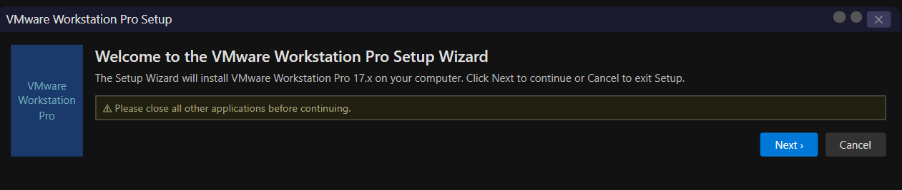

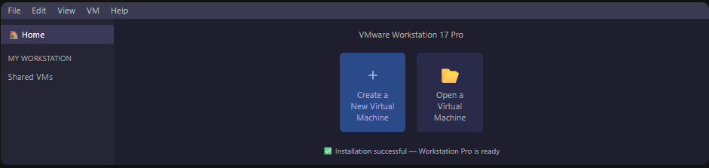

Part B — Virtual Machine Creation
Create a new virtual machine in VMware Workstation with the professional configuration specified below:
- Step 1: Click 'Create a New Virtual Machine' on the VMware Workstation home screen. Select 'Custom (Advanced)' for full control.
- Step 2: Hardware Compatibility — select 'Workstation 17.x' for maximum feature support.
- Step 3: Guest OS Installation — select 'I will install the operating system later'. This ensures a clean VM shell before mounting the ISO.
- Step 4: Guest OS — select 'Microsoft Windows' and version 'Windows 10 x64'.
- Step 5: VM Name & Location — Name: Windows 10 (64-bit). Set location to a dedicated VMs folder on your host.
- Step 6: Processor Configuration — Number of processors: 1; Number of cores per processor: 2 (total: 2 CPU cores).
- Step 7: Memory — Set to 4096 MB (4 GB). VMware recommends a minimum of 2 GB; 4 GB ensures smooth operation.
- Step 8: Network Type — Select 'Use network address translation (NAT)'. This allows the VM to access the internet through the host.
- Step 9: I/O Controller Type — LSI Logic SAS (recommended).
- Step 10: Disk Type — NVMe or SCSI (NVMe recommended for better performance).
- Step 11: Disk — Select 'Create a new virtual disk'. Size: 60 GB. Select 'Store virtual disk as a single file' for easier portability.
- Step 12: Review the VM Summary. Click 'Finish'.
- Step 13: Edit VM Settings — Attach the Windows 10 ISO: VM Settings > CD/DVD (SATA) > 'Use ISO image file' > browse to your Windows 10 .iso file.
Final VM Configuration Summary:
Setting | Value
VM Name | Windows 10 (64-bit)
CPU | 2 Cores (1 Processor × 2 Cores)
RAM | 4 GB (4096 MB)
Storage | 60 GB Virtual Disk (Single File)
Network | NAT (Network Address Translation)
Guest OS | Windows 10 x64
Hypervisor | VMware Workstation Pro 17
Screenshot Evidence:
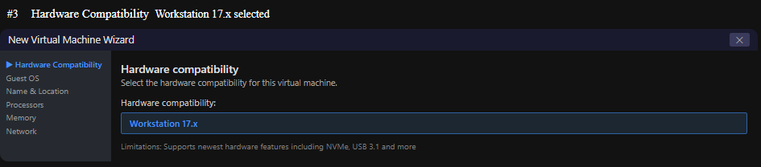

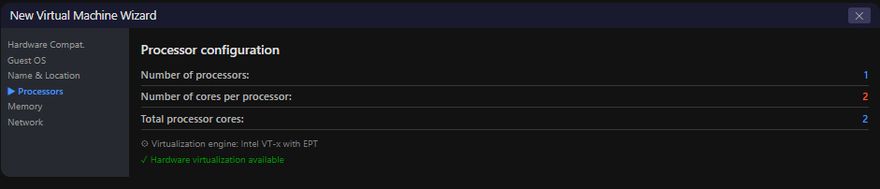

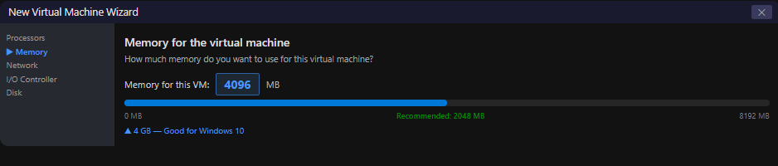

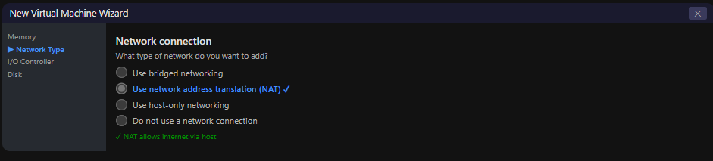

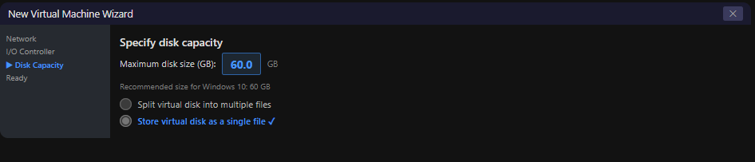

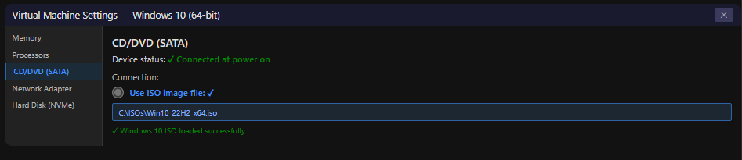

Part C — Windows 10 Installation
With the VM configured and the Windows 10 ISO attached, begin the installation:
- Step 1: Power on the VM in VMware Workstation. The VM will boot from the attached ISO.
- Step 2: When the 'Press any key to boot from CD or DVD...' prompt appears, press any key immediately.
- Step 3: The Windows Setup screen will appear. Select Language: English (United States), Time & Currency Format: your region, Keyboard: US. Click Next.
- Step 4: Click 'Install Now'. If prompted for a product key, click 'I don't have a product key' to proceed with a trial installation.
- Step 5: Select the Windows 10 edition (Windows 10 Pro recommended). Click Next. Accept the license agreement.
- Step 6: IMPORTANT — Select 'Custom: Install Windows only (advanced)'. This provides full disk control for the DiskPart partitioning step.
- Step 7: On the 'Where do you want to install Windows?' screen, press Shift + F10 to open the Command Prompt. Proceed to Part D — Disk Management.
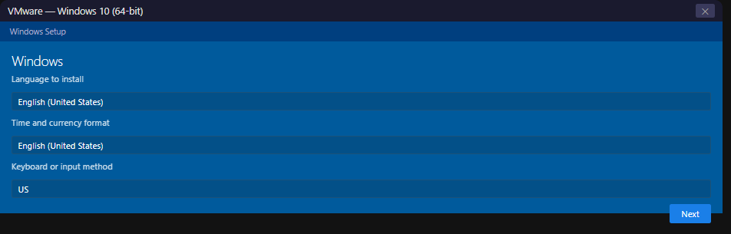
Screenshot Evidence:

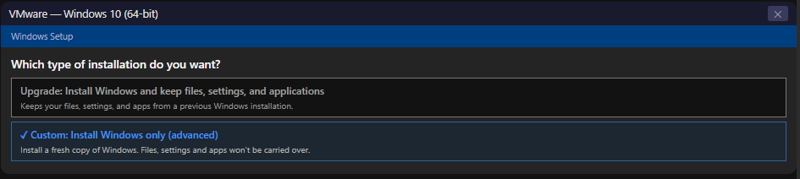

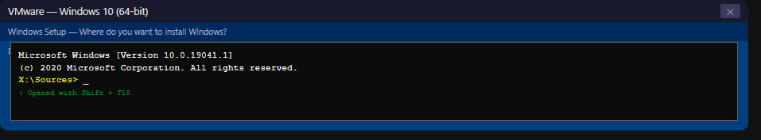

Part D — Disk Management using DiskPart
With the Command Prompt open (via Shift+F10 during Custom Installation), execute the following DiskPart commands to professionally partition the 60 GB virtual disk. Each command is documented with its purpose:
diskpart
list disk
select disk 0
create partition primary size=21000
create partition extended
create partition logical size=19000
create partition logical size=19000
list volume
select volume 1
format fs=ntfs quick
assign letter=A
Note: Repeat the last three steps (select volume N → format fs=ntfs quick → assign letter=X) for each additional volume created on your disk, incrementing the volume number and letter each time.
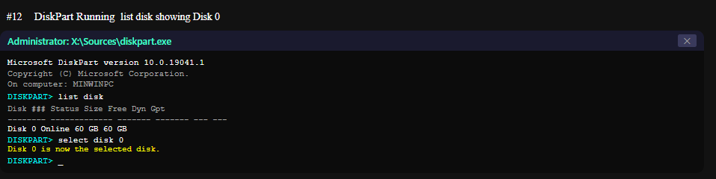

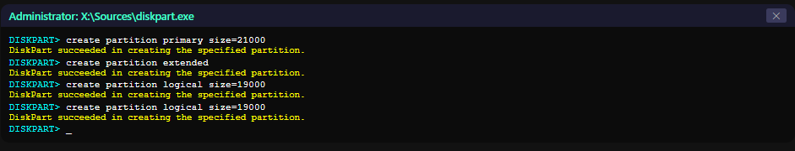

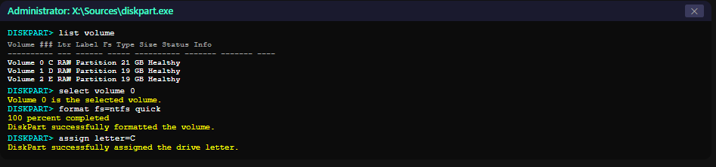

Part E — Complete Windows Installation & Initial Configuration
After DiskPart partitioning, close the Command Prompt and continue the Windows installation:
- Step 1: In the 'Where do you want to install Windows?' screen, select the 21,000 MB primary partition (the C: drive partition created by DiskPart). Click Next.
- Step 2: Windows Setup begins copying and expanding files to the selected partition. This takes approximately 5-15 minutes in a VM. The VM will restart automatically.
- Step 3: After the restart, Windows will continue installing features and updates. Allow the process to complete without interruption.
- Step 4: Out-of-Box Experience (OOBE) — Select your region and keyboard layout. For network, select 'I don't have internet' > 'Continue with limited setup' to create a local account.
- Step 5: Create a local user account. Set Username (e.g., your name) and Computer Name (e.g., ITSIMPLERA-LAB). Create a password (or leave blank for lab environments).
- Step 6: Configure Privacy Settings — for a lab VM, you can disable all optional telemetry options. Click Accept.
- Step 7: Wait for Windows to complete the final setup tasks and load the desktop.
- Step 8: Verify the installation — right-click Start > System to open System Information. Verify: Windows 10 version, CPU (2 cores), RAM (4 GB), Computer Name.
- Step 9: Open Disk Management (right-click Start > Disk Management) or run diskmgmt.msc to verify the disk partition layout created by DiskPart.
- Step 10: Install VMware Tools (VM menu > Install VMware Tools) to enable full-screen resolution, clipboard sharing, and drag-and-drop between host and guest.
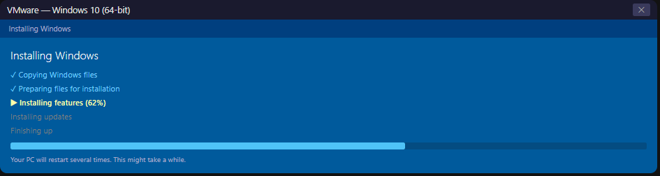
Screenshot Evidence:

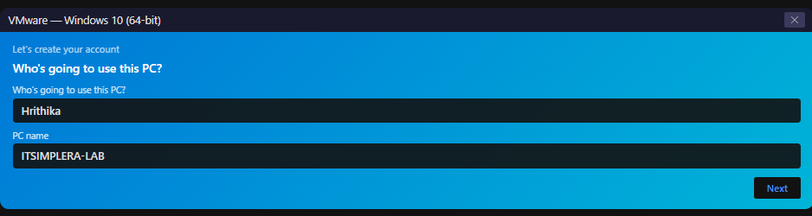

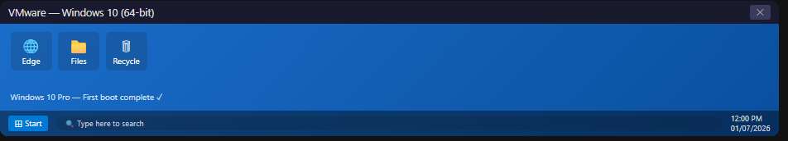

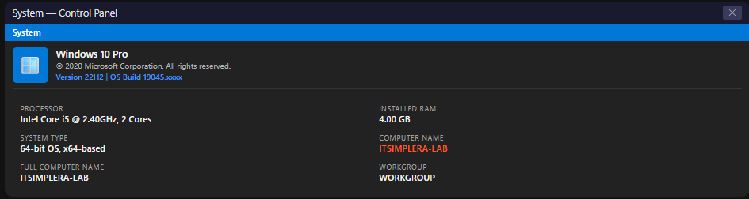

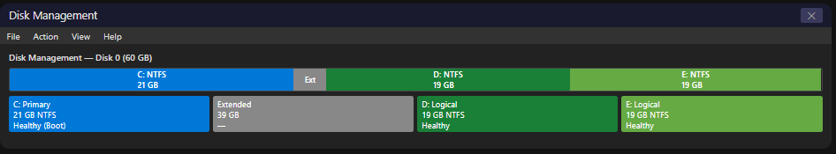

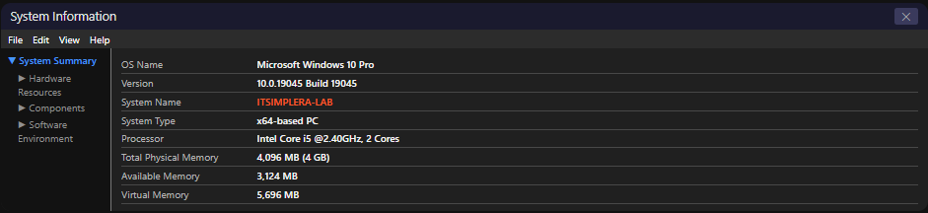

6. DiskPart Command Explanation

The table below provides a detailed explanation of every DiskPart command executed during the disk partitioning phase (Part D). Understanding these commands is essential for professional disk management:
Command | Purpose & Explanation
diskpart | Launches the DiskPart command-line utility, a powerful disk management tool built into Windows used to manage disks, partitions, and volumes.
list disk | Displays all physical disks detected by the system (e.g., Disk 0 = 60 GB virtual disk). Used to verify disk presence and capacity.
select disk 0 | Selects Disk 0 as the active disk for all subsequent commands. In a VM with one virtual disk, this is always Disk 0.
create partition primary size=21000 | Creates a primary partition of 21,000 MB (~21 GB). This will be the C: drive — the Windows OS installation partition.
create partition extended | Creates an extended partition using all remaining disk space (~39 GB). Extended partitions serve as containers for logical drives, since MBR disks support only 4 primary partitions.
create partition logical size=19000 | Creates the first logical partition (D:) of 19,000 MB (~19 GB) inside the extended partition. Used for user data or application storage.
create partition logical size=19000 | Creates a second logical partition (E:) of 19,000 MB (~19 GB) inside the extended partition. Used for additional storage or backup purposes.
list volume | Lists all volumes (partitions with drive letters) on the selected disk. Used to verify that partitions were created correctly and to identify volume numbers.
select volume 1 | Selects Volume 1 (the primary partition) for formatting and drive letter assignment.
format fs=ntfs quick | Formats the selected volume with the NTFS file system using quick format. NTFS is required for Windows installation — it supports file permissions, encryption, and large files.
assign letter=A | Assigns a drive letter to the formatted volume. Repeat select volume N → format → assign letter for each volume created on your disk.
Disk Partition Layout after DiskPart execution on a 60 GB virtual disk:
Partition | Type | Size | File System | Drive Letter
1 | Primary | ~21 GB | NTFS | C: (System)
2 | Extended | ~39 GB | N/A | N/A
3 | Logical | ~19 GB | NTFS | D:
4 | Logical | ~19 GB | NTFS | E:

7. Challenges Faced

During the implementation of this task, the following challenges were encountered and resolved:
Challenge 1: Hardware Virtualisation Not Enabled
Symptom: VMware Workstation displayed the error 'This host does not support Intel VT-x' when attempting to power on the VM.
Resolution: Rebooted the host machine and entered BIOS/UEFI settings. Located the 'Intel Virtualization Technology' (or AMD-V) option under the CPU/Advanced settings and enabled it. Saved changes and rebooted. VMware was then able to start the VM successfully.
Challenge 2: Windows Setup Did Not Detect Disk Partitions After DiskPart
Symptom: After running DiskPart commands and closing the Command Prompt, the Windows Setup partition screen showed only unallocated space or incorrect partitions.
Resolution: Returned to the DiskPart CLI (re-opened via Shift+F10) and ran 'list partition' to verify partition creation. Ensured the primary partition was selected and formatted before proceeding. Refreshed the partition list in Setup.
Challenge 3: VM Display Resolution Too Low After Installation
Symptom: Windows 10 desktop appeared in a low resolution (e.g., 800×600) with no option to increase it.
Resolution: Installed VMware Tools from the VM menu (VM > Install VMware Tools). After installation and restart, the display resolution options expanded to the full monitor resolution and clipboard sharing was enabled.
Challenge 4: Boot Sequence Skipped ISO Boot
Symptom: The VM powered on but booted to a black screen or 'Operating system not found' instead of the Windows Setup.
Resolution: In VMware VM Settings, confirmed the CD/DVD drive was set to 'Use ISO image file' and that 'Connect at power on' was checked. Also verified boot order: VM > Power > Power On to Firmware > confirmed CD-ROM was first in the boot order.

8. Learning Outcomes

Upon completing this task, the following skills and knowledge were acquired:
- Gained a solid theoretical foundation in MCSE, System Administration roles, and the responsibilities of IT infrastructure professionals.
- Understood the difference between Type-1 (bare-metal) and Type-2 (hosted) hypervisors and their appropriate use cases in enterprise vs. lab environments.
- Successfully installed and configured VMware Workstation Pro as a professional virtualisation platform.
- Created a fully configured Windows 10 virtual machine with precise hardware specifications (2 cores, 4 GB RAM, 60 GB storage, NAT networking).
- Developed proficiency in Windows installation procedures — specifically the Custom Installation method and navigating the Windows Setup environment.
- Mastered DiskPart CLI commands for professional disk partitioning: creating primary, extended, and logical partitions; formatting with NTFS; and assigning drive letters.
- Understood the MBR partition scheme and the relationship between primary, extended, and logical partitions.
- Configured initial Windows 10 settings including local user account creation, privacy settings, and system verification.
- Developed technical documentation skills through structured screenshot capture and report writing.
- Built a reliable, isolated lab environment ready for future internship tasks involving Active Directory, DNS, DHCP, and server deployment.

9. Conclusion

This task successfully established a professional virtual lab environment using VMware Workstation Pro and Windows 10 — forming the foundational infrastructure for all future internship activities at ITSimplera Institute.
The implementation covered the complete lifecycle of virtual machine deployment: from theoretical understanding of MCSE concepts and virtualisation technologies, through hands-on VMware installation and VM configuration, to professional disk partitioning using DiskPart CLI and final Windows 10 setup and verification.
The most technically significant aspect of this task was the use of DiskPart during Windows Setup (accessed via Shift+F10) to implement a professional three-partition disk layout — a technique used in real-world enterprise deployments to separate OS, applications, and data onto distinct volumes for better management, security, and performance.
The virtual machine created in this task — a clean Windows 10 (64-bit) installation with 2 CPUs, 4 GB RAM, and a professionally partitioned 60 GB disk — is now ready to serve as the primary laboratory environment for Week 2 onwards, where tasks will include Active Directory configuration, Windows Server deployment, and network services management.
This task demonstrated that building a reliable lab environment is not merely a technical exercise but a foundational professional skill that mirrors real enterprise deployment workflows.

10. References

- Microsoft Corporation. (2024). Windows 10 documentation. Microsoft Learn. https://learn.microsoft.com/en-us/windows/
- Microsoft Corporation. (2024). DiskPart command-line reference. Microsoft Learn. https://learn.microsoft.com/en-us/windows-server/administration/windows-commands/diskpart
- VMware Inc. (2024). VMware Workstation Pro user guide. Broadcom Documentation. https://docs.vmware.com/en/VMware-Workstation-Pro/
- Microsoft Corporation. (2024). MCSE certification overview. Microsoft Learn. https://learn.microsoft.com/en-us/certifications/mcse/
- National Institute of Standards and Technology. (2011). The NIST definition of cloud computing (SP 800-145). NIST. https://doi.org/10.6028/NIST.SP.800-145
- VMware Inc. (2024). Types of virtualisation. VMware Glossary. https://www.vmware.com/topics/glossary/content/what-is-virtualization
- Microsoft Corporation. (2024). Windows architecture overview. Microsoft Learn. https://learn.microsoft.com/en-us/windows-hardware/drivers/kernel/
- ITSimplera Institute. (2026). Week 1 — Task 01: Building your professional virtual lab environment. System Administration & Infrastructure Services Internship.

11. Evaluation Criteria

Component | Marks | Status
Documentation (Step-by-step report with screenshots) | 10 | Completed
LinkedIn Submission (Professional task post) | 50 | Completed
GitHub Repository / Documentation | 10 | Completed
Technical Interview (Google Meet) | 30 | Pending
Total | 100
Important Notes:
- This report has been completed independently. All screenshots are original captures from my virtual machine.
- All practical steps have been personally implemented — this is not an AI-generated theory report.
- LinkedIn post will be published upon task submission with professional documentation of the work.
- GitHub repository contains the complete documentation and DiskPart scripts for this task.
- Technical interview is pending scheduling by the Team Lead.


ITSimplera Institute
System Administration & Infrastructure Services Internship
Week 1 — Task 01 | Submitted: June 2026 | Deadline: July 4, 2026

